SQL Injection
Category: Web Exploitation 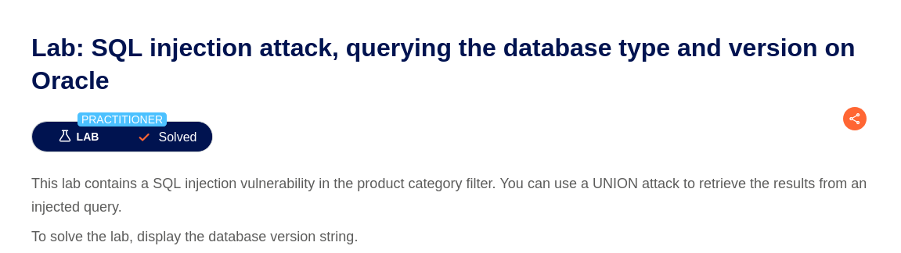
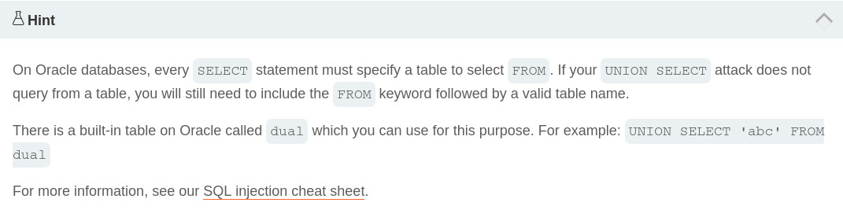

First, Go to one of the category pages (here i choose ‘Pets’) and Intercept with a burp suite
Then sent to the repeater. Because when using union select in oracle we must know how many columns exist, we’ll check how many columns does that table has, inject:
' ORDER BY 2– (success)
' ORDER BY 3– (error)

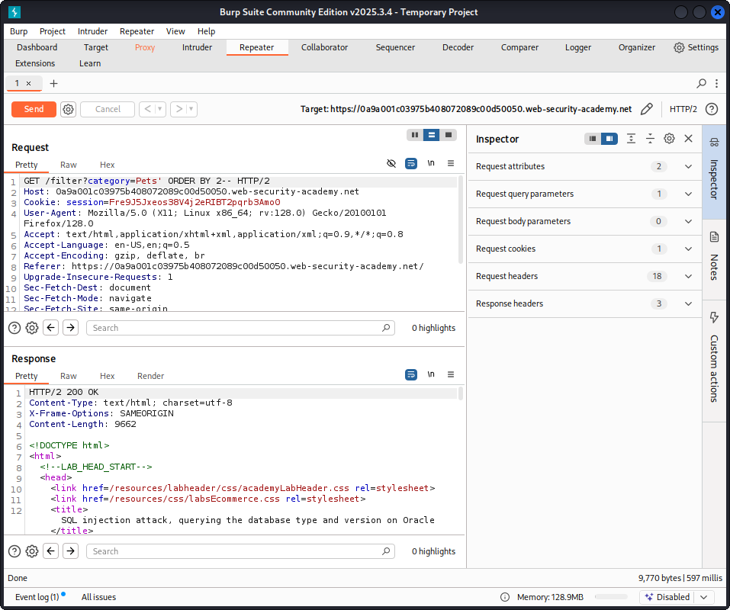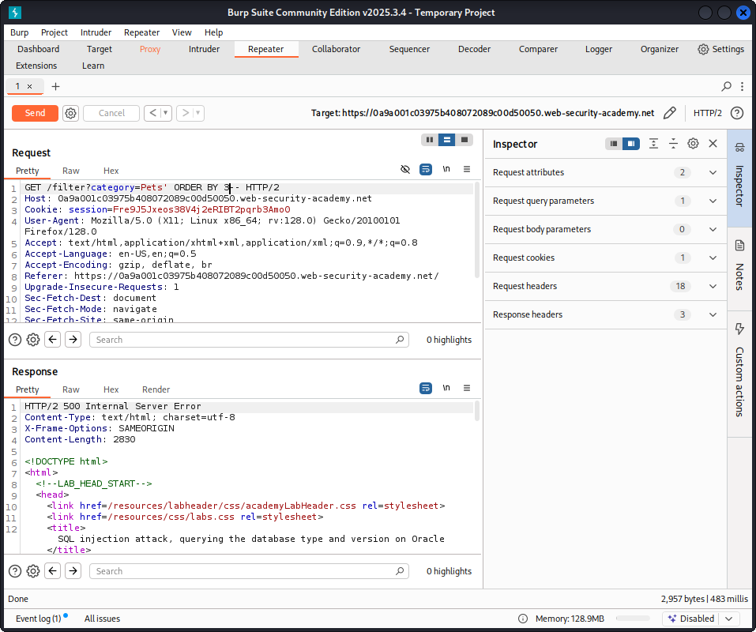

So, there are two columns, now we use the union select to reveal the database version string:
'+UNION+SELECT+banner,+null+FROM+v$version--
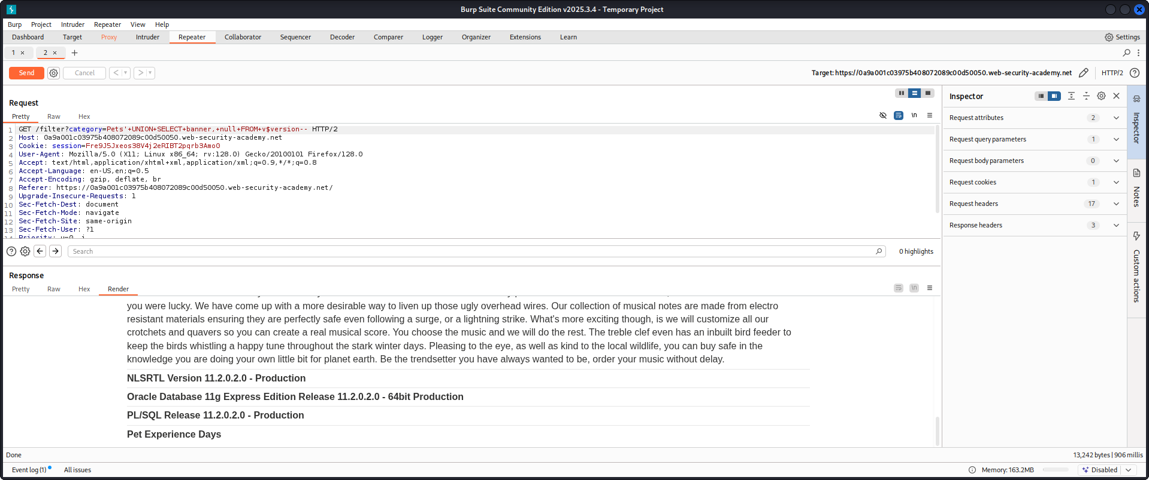
Gotcha!

DOM XSS
Category: Web Exploitation
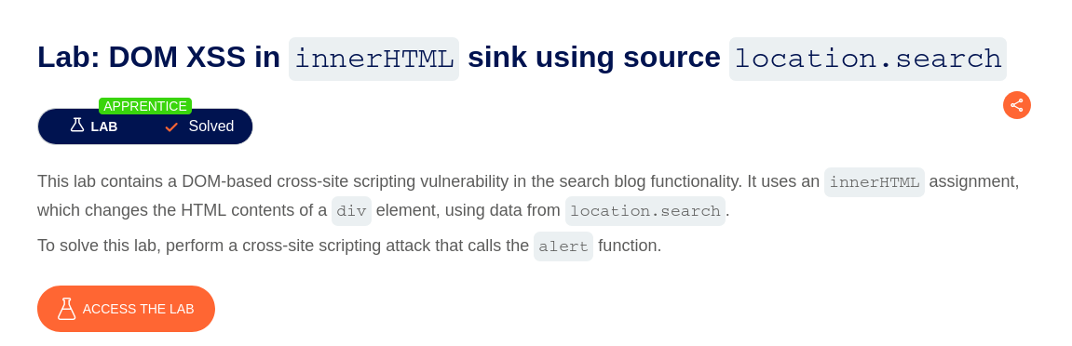

Since they are putting the input value using .innetHTML, which detects and won't execute the ‘<script>’, we need to use another tag. Here i use <img>:
<img src=1 onerror=alert(‘haha’)>
Then click ‘search’.

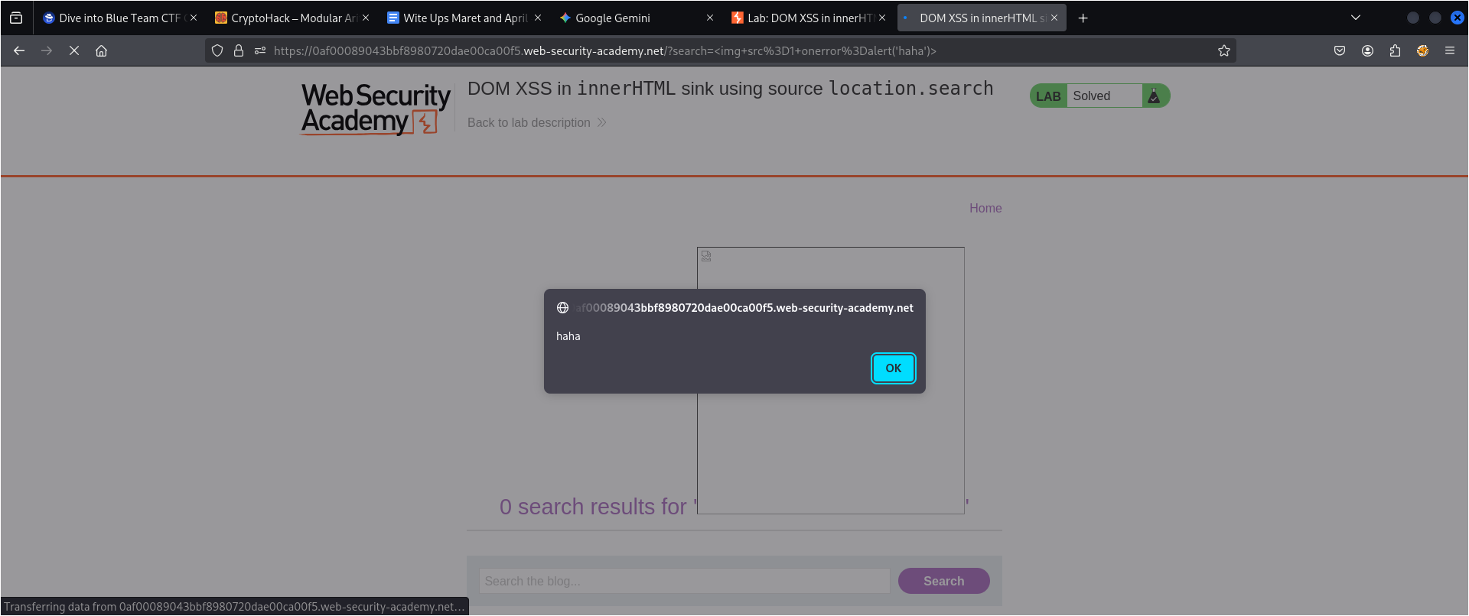

DOM XSS
Category: Web Exploitation
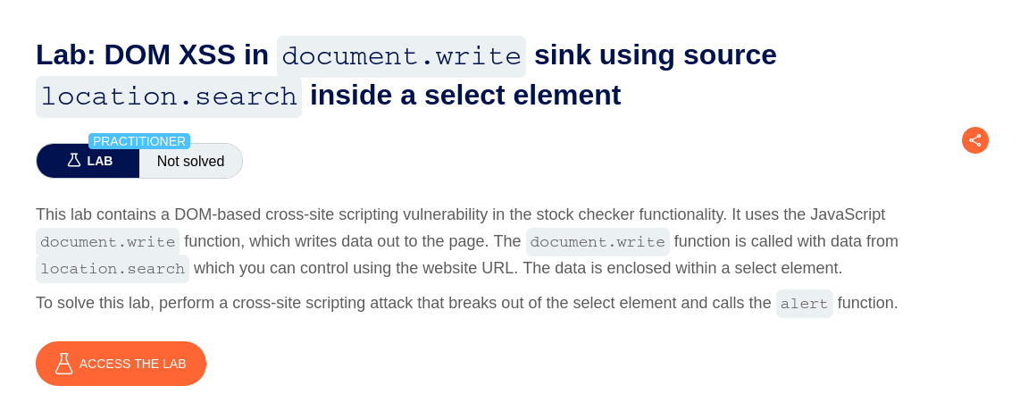
First, check the product page. The lab says the "Stock Checker" is vulnerable because it uses document.write to grab the storeId from the URL and dump it into a dropdown.

Even if the URL doesn't show it, I found the parameter name by hitting "Check Stock" and intercepting the POST request in Burp. It showed:
productId=3&storeId=Paris.

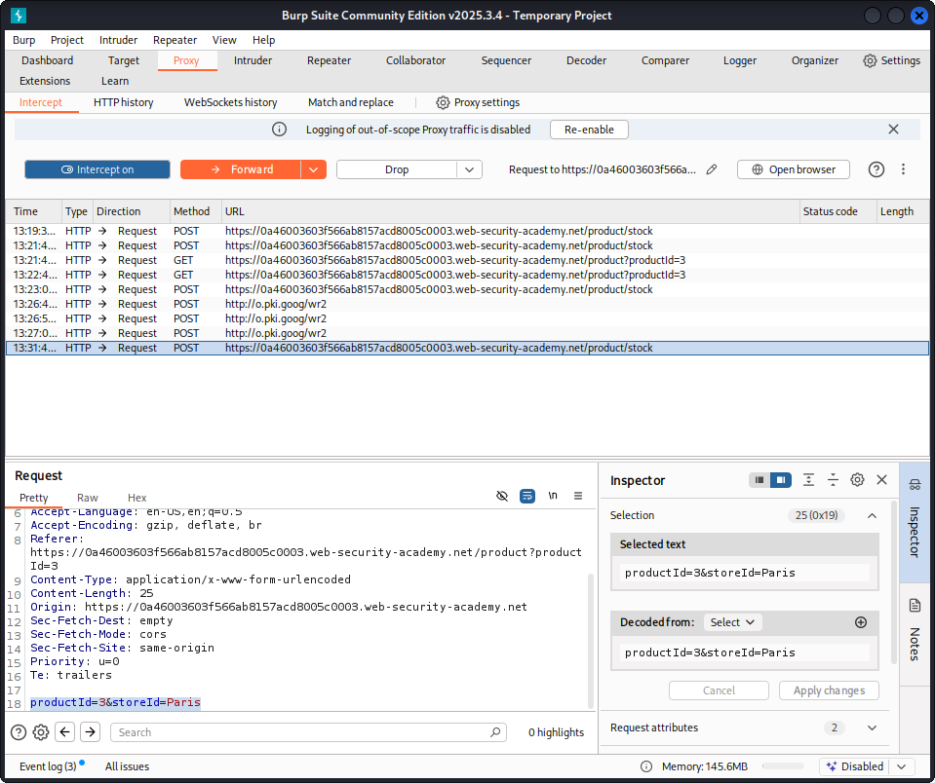

Then i manually inject the payload to the serach bar:
The initial url is like this:
‘https://0a46003603f566ab8157acd8005c0003.web-security-academy.net/product?productId=3’
It does not have the storeId, so we add it and the injection become:
product?productId=1&storeId="></select><img src= onerror=alert(‘haha’)>

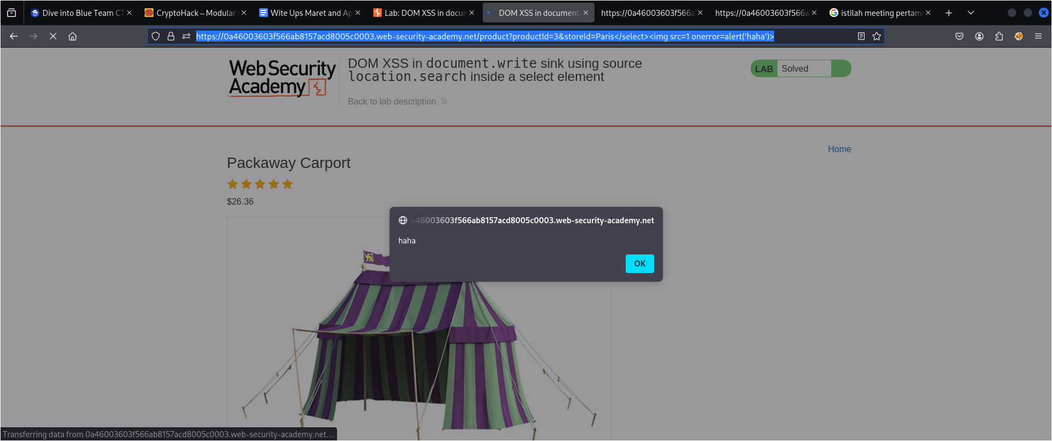
Gotcha!

